# The opportunism of celebrating Nobel laureates as 'Japanese' despite foreign citizenship

TOKYO -- Syukuro Manabe, a 90-year-old senior meteorologist at Princeton University who laid down the foundations for predicting global warming and was among the winners of the Nobel Prize in Physics in 2021, has received praise from Japanese nationals saying they are "proud of him as a Japanese person," despite his American citizenship. What is it that makes Japanese people call other people "Japanese" only when it suits them?

"Dr. Syukuro Manabe." Applause erupted on Dec. 6 at the National Academy of Sciences in Washington as Manabe took to the stage and received his Nobel Prize medal and certificate.

Born in western Japan's Ehime Prefecture, he received his doctorate from the University of Tokyo. Since arriving in the United States in 1958, Manabe has spent almost all of his life in research there.

At the press conference immediately after Manabe was announced as a recipient of the Nobel Prize in Physics, he explained why he never returned to Japan and took American citizenship instead. "In Japan, people always worry about not disturbing each other. And they have a very harmonious relationship... In the U.S., I can do things I like, and I don't worry too much about what other people feel. Because as a matter of fact, I don't want to hurt other people's feelings, but I'm not observant enough of other people to figure out what they think... That's one reason I don't want to go back to Japan. Because I'm not capable of living harmoniously."

Meanwhile in Japan, not only did Prime Minister Fumio Kishida state, "I'm extremely proud as a Japanese person," Manabe has been celebrated widely as "Japanese." Some media outlets made lists of "Japanese" Nobel laureates, with the annotation that he and some others were U.S. citizens, and simply reported Manabe was the 28th Japanese Nobel Prize winner.

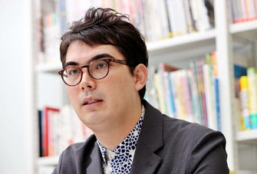

Julian Keane is seen in Tokyo's Setagaya Ward on Nov. 22, 2021. (Mainichi/Kentaro Ikushima)

"To widen the definition of who is 'Japanese' when it's internationally beneficial, and to narrow it when it's not, is characteristic of Japanese society," said Julian Keane, a sociologist and special lecturer at Showa Women's University in Tokyo. An expert on the topic of "hafu" or biracial people, he has an American father and a Japanese mother.

Article 11 of Japan's Nationality Law stipulates that "A Japanese national shall lose Japanese nationality when he or she acquires a foreign nationality by his or her own choice." This means Manabe legally stopped being Japanese when he became a U.S. citizen.

According to a study by Maastricht University in the Netherlands, as of 2020, 76% of countries recognized that a single person could have multiple nationalities. Cases like Japan, where people are forced to abandon their previous nationality, are extremely rare.

"Overseas, there is the fundamental idea that taking away one's roots and identity demands extreme caution. In contrast, in Japan, the state easily takes that away from you, but when it comes to people who have made great accomplishments, they are emphasized as being 'Japanese,'" Keane said.

It was the same when Japanese-British author Kazuo Ishiguro won the Nobel Prize in Literature. Ishiguro was born in Nagasaki, but only lived there until age 5. Still, a wealth of discourse tried to find something pointing to a certain "Japaneseness" in him.

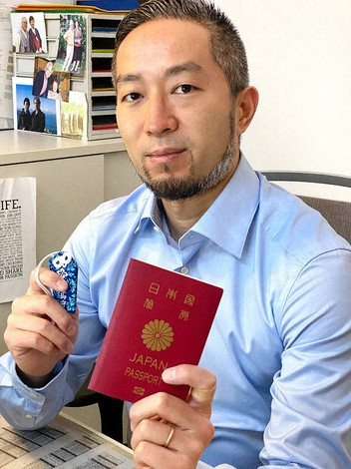

Masato Iwamura is seen in this photo provided by him.

What do Japanese nationals who have lived for many years outside the country feel about the situation? Masato Iwamura, 44, has lived in Switzerland for 20 years, and told the Mainichi Shimbun in an online interview, "If you make it big, you're a hero in the motherland. But if you end up a nobody, you're abandoned."

Iwamura arrived in Switzerland as a foreign student. After studying at a local university, he began working at a company selling cigars. Five years ago, he received residency status close to permanent residency. He currently has no plans to return to Japan, and is considering Swiss citizenship. The odds he'll get it if he applies are reportedly high, but he can't help having second thoughts when he knows he would lose his Japanese citizenship.

"Both my friends and my family are in Geneva," Iwamura said. "Under such circumstances, it's only natural for me to want to obtain Swiss citizenship. Without it, I am subject to certain restrictions when it comes to work. But why should I have to be stripped of my Japanese citizenship? My identity is Japanese."

In March 2018, eight men and women, including Iwamura, filed a lawsuit at the Tokyo District Court for confirmation they could keep their Japanese citizenship after obtaining foreign citizenship. The case was dismissed in January 2021. An appellate trial is now taking place in the Tokyo High Court, and it was under these circumstances that news broke of Manabe winning the Nobel Prize.

"The first thing that bothered me was that even though he is an American, his name was written in kanji on a Japanese government website. Among the plaintiffs in our case are people who already lost their Japanese citizenship and therefore even if they return to Japan, their names are no longer rendered in kanji on public documents. Names are imbued with the hopes parents have for us, so it is an extremely sensitive topic that comes entangled with the loss of citizenship," Iwamura said.

While some people are celebrated even without citizenship, some feel they have been cut off from their homeland. To Iwamura, Japan's handling of the issue looks very opportunistic.

At a time when globalization has progressed and many have left Japan to flourish in various fields around the world, the Nationality Law's provisions have been criticized as anachronistic.

Iwamura said, "I don't want future generations to face the same suffering and problems we have." Meanwhile, Keane said, "At the very least, with civilians, it's hard to think of any situations in which it would be detrimental to the country to allow its citizens to have multiple nationalities. The demerits of one being stripped of one's Japanese citizenship are far greater."

(Japanese original by Yukinao Kin, Digital News Center)