# One man's campaign against his 'anti-fun' city

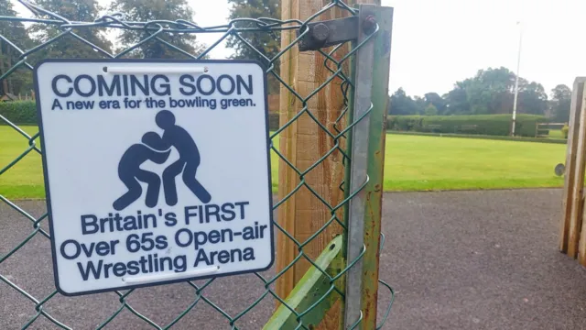Carp

Carp says he wants his signs to "make people laugh"

One man has launched a campaign in a bid to change what he calls the "fun deficit" in his city.

Calling himself the Chichester Anti-Recreation Partnership (Carp), he has put up spoof signs around central Chichester to make people laugh, but also highlight issues impacting the community.

Carp, who lives and works locally and does not want to be identified, told the BBC he wanted to satirise the city's "overregulation and lack of fun" after he noticed that warning or prohibited signs were "everywhere".

Chichester District Council said Chichester was a "vibrant place to live, work and visit". They cited a [recent study](https://www.alliancesecurity.co.uk/best-places-to-live-in-west-sussex/) ranking it as the best place to live in West Sussex.

"I absolutely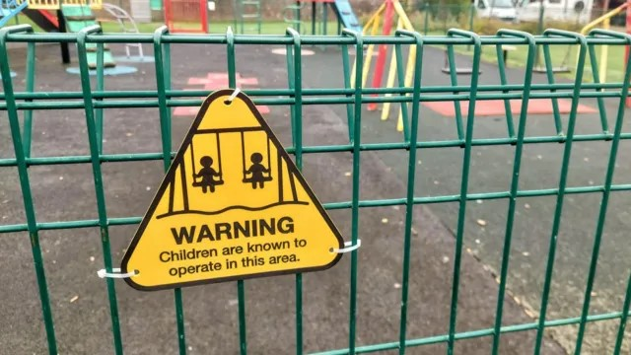 adore Chichester," Carp said.

"But it does have some notable gaps - particularly when it comes to fun and things for younger people to do.

"Over time, it’s become increasingly focused on catering to older residents," he continued.

"While it’s great that there’s so much for those who’ve retired, it feels like that’s come at the expense of forgetting about the younger generations."

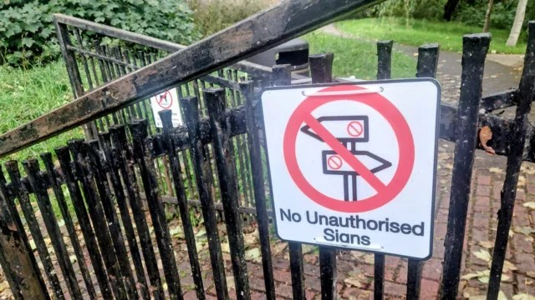Almost half of Chichester residents are over 50, [according to the Office for National Statistics](https://www.ons.gov.uk/visualisations/censusareachanges/E07000225/). Chichester District Council told the BBC it was working hard to deliver exciting events for all ages, including laser light shows, music events and street parties. "All of these have been really well received and attended," a council spokesperson said. Carp said he also wanted to "raise awareness "about wider problems affecting the community, such as "the sewage crisis, poor state of roads and uneven pavements".

"Humour has this unique ability to disarm people - it lowers their defences and allows them to consider issues from a fresh perspective," he said."It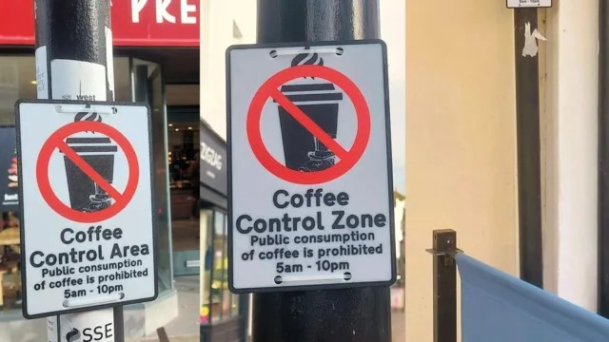 frames problems in a way that’s more approachable and less confrontational, which makes it easier to get your message across and spark discussions."

Carp says he has put up around 35 signs since starting his campaign in August. He typically photographs his handiwork and uploads it on social media.

Carp said his message was "gaining momentum quickly" - with some images going viral on TikTok - though he added the council was quick to take the signs down.

He said he hoped the signs could help shift public opinion in favour of making the city more vibrant and fun, though he said there were some who would push back against this.

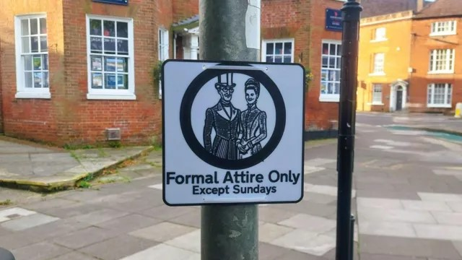

He suggested a "big difference" could be made if more nightlife for young people was brought to Chichester, plus bringing back the ice rink and creating more children's play areas.

Chichester District Council told the BBC it was investing £814,000 in refurbishments to several play areas in Chichester.

"Families and young people are a really important part of our community," the spokesperson said.

The local authority added it had created a dedicated evening and night-time working group, which was collecting views on what young people would like to see in the city in the future.

"I feel like I’m contributing to making the city a better place for everyone," said Carp.

"Whether it’s a smile, a conversation, or just getting people to think about the issues in a new way, I think the impact justifies the effort."